AguaClara Public Relations

AguaClara Cornell | Isa Kaminsky, Madeleine Lee, Helen Hsu

Complete Subteam Guide

For Incoming Subteam Members

Spring 2018

Table of Contents

**Section I: Mission of Public Relations** 3

Mission of AguaClara as an Organization 3

Mission of AguaClara Cornell 4

Mission of Public Relations 4

**Section II: Project Overview** 5

Branding 5

Logo and Name 5

Brand Book 5

Social Media 6

Facebook 6

Instagram 6

YouTube 7

Snapchat 7

Twitter 8

LinkedIn 8

Passwords and Access 8

Promotional Materials 9

Introductory Presentation 9

Press Kit 9

Quarter Cards 10

Brochure 10

Poster 10

Trifold 10

Video 11

Newsletter 11

Internal Affairs 12

Merchandise 12

Photography 13

Team Member Interviews 13

External Relations 14

Alumni Outreach 14

Networking Database 14

Donor Relations 14

**AguaClara Reach Relations 14**

**Section III: Notes and Suggestions 15**

Tips and Advice 15

Management 15

Software 15

A Parting Motivational Note 15

# Section I: Mission of Public Relations

## 

## Mission of AguaClara as an Organization

Founded in 2005, AguaClara pioneers research in community-scale water treatment technologies.  AguaClara, a program that would develop and implement new sustainable and gravity-powered drinking water and wastewater treatment technologies for communities.

The overall mission of AguaClara is now being carried out by AguaClara Cornell, AguaClara Reach, and partner organizations throughout the countries in which AguaClara has a presence. Through these collaborations, AguaClara plants now provide safe water on tap to over 65,000 people, with the flagship plant in Ojojona, Honduras and other plants in India.

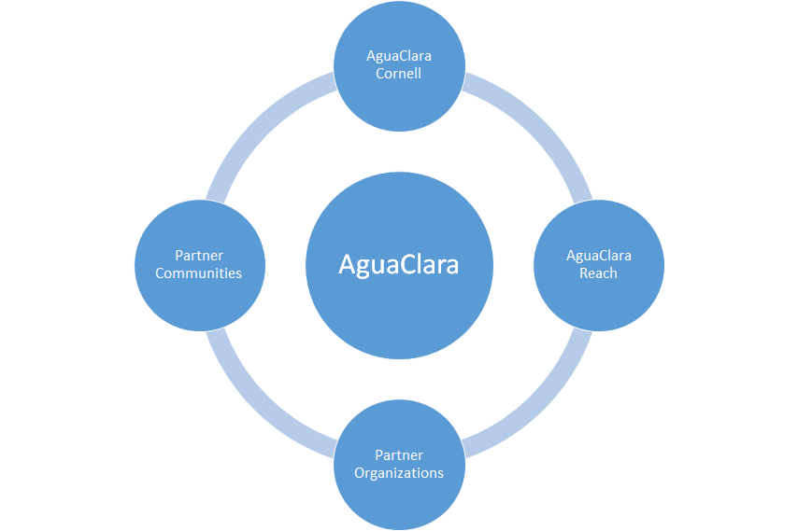

AguaClara Cornell focuses on the research of the designs and technologies as it acts as the “design think tank.” AguaClara Reach uses these technologies and trains organizations to design and deploy the gravity-powered water treatment plants within communities. Throughout the whole system, there is a consistent feedback loop of learning and new research questions are always presented and shared to each organization.

## Mission of AguaClara Cornell

Below is the official mission statement of AguaClara Cornell:

(Please note the wording is not to be changed or altered without consulting Monroe, Team Leads, and Going Global RA. Each word was specifically selected and placed with intent.)

AguaClara Cornell upholds and protects the fundamental human right to access safe drinking water. We are committed to the ongoing development of resilient, gravity-powered drinking water and wastewater treatment technologies. Students lead the innovation process, learn from each other, and foster a collaborative environment where diversity is celebrated, failures are learning opportunities, and success is shared. We research, invent, and design technologies that are implemented by partner organizations and managed by communities to bring *safe water on tap!*

## Mission of Public Relations

Below is the official mission statement of Public Relations at AguaClara Cornell:

Public Relations of AguaClara Cornell focuses on increasing overall exposure of the project team within Cornell and the global community. Public Relations creates and manages a consistent brand image that communicates AguaClara Cornell’s innovative, minimalistic, and sustainable ideals. Internal team pride and campus exposure are increased by designing team merchandise, maintaining a regular social media presence, and overseeing recruitment materials. Promotional materials and the brand book ensure a uniform message of AguaClara Cornell’s mission is promoted to external sources and maintained within the team.

# Section II: Project Overview

## 

## Branding

Branding is very important to maintaining AguaClara Cornell’s image.

### Logo and Name

As part of the rebranding that took place in Spring 2018, the Public Relations team made changes to AguaClara’s logo and name. For the logo, the “hand and water drop” design was replaced with the “water drop within a water drop” design. The new design is similar to that of AguaClara Reach and shares the same colors. We decided to redesign the AguaClara Cornell logo because the original design had negative connotations, as the hand implied handouts or charity, which is not the message AguaClara Cornell wants to send. The new logo is more neutral and has no negative connotations.

As for the name, we added “Cornell” to our name to differentiate ourselves from AguaClara Reach while still maintaining a uniform identity across AguaClara organizations. Our association with Cornell University also gives us credibility.

For complete explanation of our process, [click here](https://drive.google.com/drive/search?q=aguaclara%20reach) for the official press release of the new AguaClara Cornell logo.

This [folder](https://drive.google.com/drive/folders/1UEnbH0do9qcK7NgPnZzi-_TkN3WuRb6S) contains all the iterations of the logos during this process.

|  |  |
| --- | --- |
| https://lh6.googleusercontent.com/1Us6ht-hm_LDW3uE_Xr56E9fW9vmViWWdQ-8bZvKLoYN3pbC7C0ccofLNIF-qXYC-_qdFpMLqS15B2nH3mVxoOc_kZhZ_EcXoiRP7eFsx1cXz38RdpNxpxCVxsiZERIIVEdmh0ls  *The previous AguaClara logo.* | https://lh3.googleusercontent.com/_cO08fy6E6i143fese_6_24BY99pn-LxWZe6_0FfWCOylBrD39IXkw-EjwqgG4xEzi_EcrvZhBGfJPqBgw9hdQ9VtxDHy9EgE3es2NeCsYPk-LA4AognYRexcPtcuuYXsRneHwuZ  *The current AguaClara logo.* |

### Brand Book

The brand book helps to maintain a uniform brand. It details the proper way to use AguaClara’s logos, fonts, and colors, as well as the proper tone of voice. Anyone who creates materials that may be publicized must consult the brand book in advance. The brand book should be easily available on GitHub or on the AguaClara website.

In the future, make sure the brand book is followed appropriately and properly. Update brand book as needed, specifically regarding fonts and colors. The logo should not have to be changed, but fonts and colors are subject to change if there are new fonts and colors that fit our brand.

Click [here](https://drive.google.com/file/d/1vCEGmYPRn1FvsxJVUDpq12nZ5j8xLnoE/view?usp=sharing) for a link to the brand book.

## Social Media

AguaClara Cornell has a presence on Facebook, Instagram, Twitter, YouTube, and Snapchat. Through an active social media presence, we hope to help outsiders understand the work we do.

### Facebook

Our [Facebook](https://www.facebook.com/CUAguaClara/) page has the largest following of all our social media, and therefore is the most important page when it comes to outreach. Not only is this page used as a social media site for posting updates and images, it is also used as a way for people from all over the world to contact us.

Currently, the Facebook page’s main use by PR has been for Spotlight posts that highlight AguaClara members and what they do. The Spotlight posts should be posted at least once a week, and choosing a specific day on which they are consistently posted is always a good idea.

In the future, updates on progress in research or development of AguaClara technology should also be posted on the Facebook when possible.

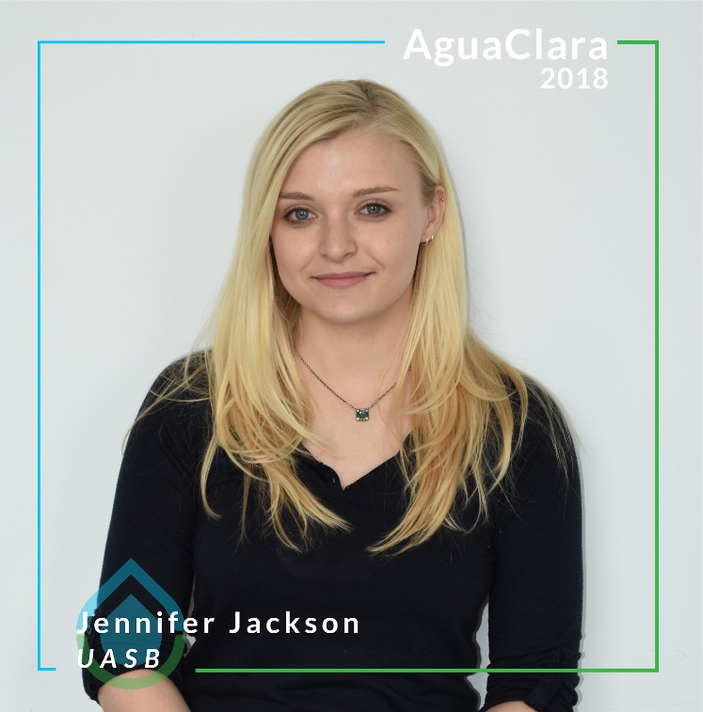

*Spotlight photo of Jennifer Jackson posted on 04/20/18.*

Click [here](https://drive.google.com/file/d/1BvnOnu16_cZp8UfBCA0eTNAizWjuD4rM/view?usp=sharing) for a link to the Spotlight frame. Feel free to create a new frame for each new semester.

### 

### Instagram

The AguaClara [Instagram](https://www.instagram.com/cuaguaclara/) has a small following, but a large potential specifically in attracting young people. Therefore, the quality of this page is very important. The Instagram is focused more on fun and has a more colorful aesthetic than the Facebook. The Instagram should not be filled with dark pictures in the lab, rather, try to post a variety of photos with bright colors.

So far, the Instagram has been used to update its followers on AguaClara’s trip to Honduras and work accomplished by different subteams. The captions posted by Public Relations tend to be quirky and fun. The Instagram can also be used to highlight AguaClara’s progressive nature. For example, we honored all the women in AguaClara with a post on Women’s Day, and we highlight our women engineers.

The main goal for Instagram in the future is to get a larger following. Also, from now on, the Instagram pictures can be linked to the Facebook.

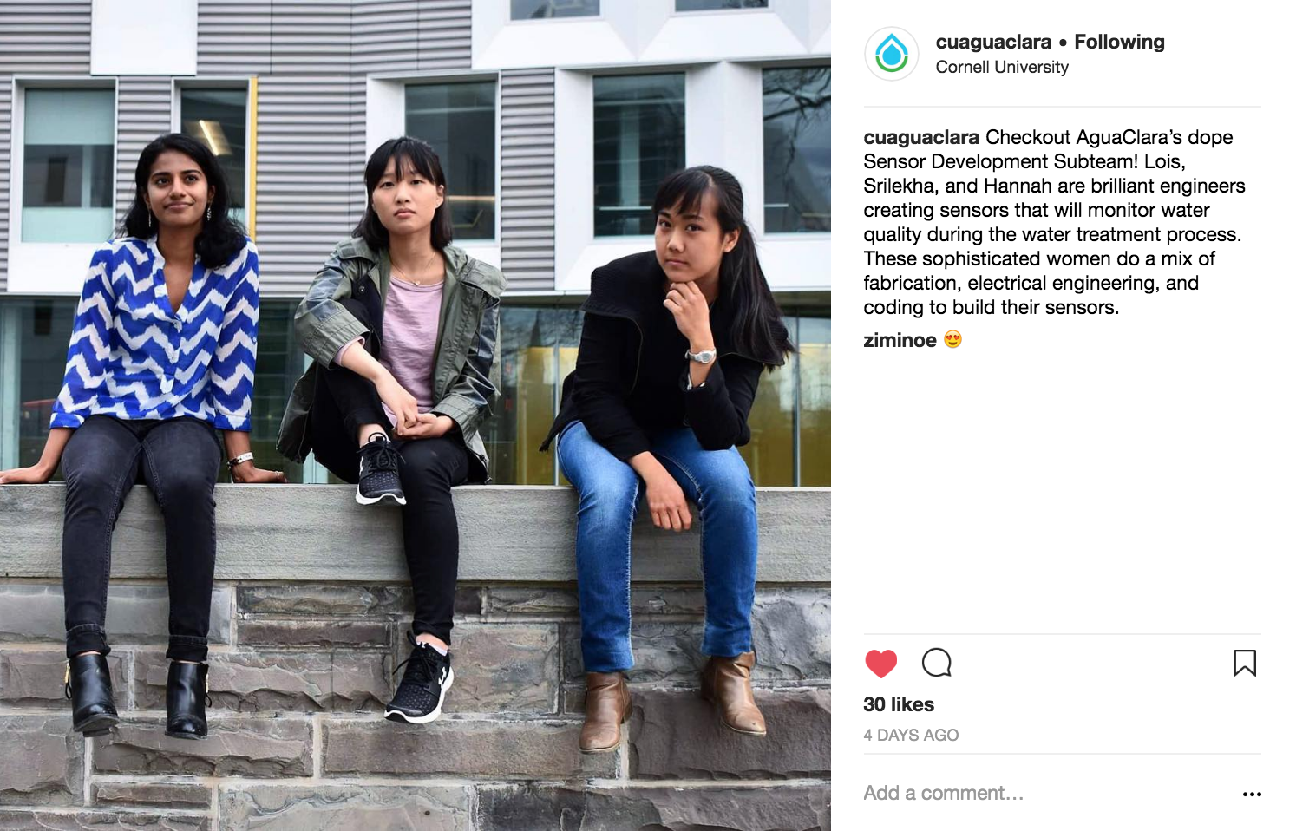

*Example Instagram Post Posted on 05/13/18*

### YouTube

There are two Youtube Pages, both linked to [cuaguaclara@gmail.com](mailto:cuaguaclara@gmail.com). The old page is named [cuaguaclara](https://www.youtube.com/user/cuaguaclara/videos) while the new page is named [AguaClara Cornell](https://www.youtube.com/channel/UCQ4wmjlqWO-1SG0Ox0uQhBQ?). The old YouTube page is cluttered with outdated technical videos and raw footage. The new YouTube channel named AguaClara Cornell should from now on only be featuring official videos.

In the future, please go through and determine which videos from the old page should be re-uploaded in the new account.

### Snapchat

An AguaClara Snapchat currently exists and has 22 members. The purpose of the Snapchat group was to provide an informal means by which different subteams can find out about other subteams’ projects and to bring subteam members closer together.

However, members post very rarely to the group, so in the future, Public Relations members can decide if they wish to revive the AguaClara Snapchat. If it is to be continued, a potential idea would be to emphasize that it can be used for the team members to be updated on what other subteams are working on. Perhaps there can be a snap whenever there are research breakthroughs.

### Twitter

As of now, AguaClara has not maintained regular activity on [Twitter](https://twitter.com/cuaguaclara?lang=en). Public Relations occasionally checks the AguaClara Twitter account to see if the team has been tagged in tweets by others. However, if future teams see value in becoming more active on Twitter, this is always an option.

### LinkedIn

AguaClara Cornell has a LinkedIn profile that is the owner of the [business page](https://www.linkedin.com/company/aguaclara-at-cornell) and the group.  The purpose of the group and the business page is to connect alumni and current members.

In the future, encourage future members and alumni to add AguaClara Cornell to their personal profiles and join the AguaClara group. Accept people who request membership to the AguaClara group after checking to see if they are current members or alumni.

### Passwords and Access

Click [here](https://docs.google.com/spreadsheets/d/1fKbf8DX7SRVBMCtpwTsbevCdJE18_4j3YW0fJHD_Xz8/edit#gid=0%5C) for a link to the associated emails and passwords for the social media accounts.

## Promotional Materials

### Introductory Presentation

There are two introductory presentations that should be made: one regarding internal Going Global affairs and another regarding the overall project team AguaClara Cornell as a whole.

The introductory presentation regarding Going Global will be created over the summer and this will act as a placeholder until the final presentation is completed. When it is done, it is expected to be used for Going Global information sessions during recruitment.

In addition, a general AguaClara Cornell presentation should be created for outreach events. The goal is to allow the audiences to understand the mission of AguaClara in a concise, engaging, and professional way. Designs should be clean, minimalistic, and avoid extensive word use and bullet points.

Both presentations should convey:

* The mission of the subject covered
* Subteam/Learning Opportunities
* The family atmosphere of AguaClara

### Press Kit

A press kit is a package of promotional materials that is sent to a media outlet. It details basic information about AguaClara and other things a media outlet would want to know if they are writing an article about AguaClara. It is meant to be easily accessible from the “Press” tab on the AguaClara website. Click [here](https://www.dropbox.com/sh/luhn3j4isfgw1ji/AADJVZPCopZUt_imBskLoKp6a?dl=0) for an example of a press kit from LuminAID.

The press kit will be composed of a series of one-pagers that provide information about different aspects of AguaClara. These materials are written in the third person in a professional manner with the intention that any donors may use the information provided at any given moment.

Currently, content is completed for the following one-pagers: “About AguaClara” (basic project team information), “The AguaClara Difference” (describes our technology), and “The AguaClara Timeline.” Photos are still needed for the aforementioned one-pagers. Content and photos are also needed for the following one-pagers: “Lead the Way: The Director and Team Leads” (executive bios) and “Our Impact” (describes our work in Honduras, Nicaragua, and India). Click [here](https://docs.google.com/document/d/1ZuP32uVNIJNwq7lBiktjStvAD__PzkWZrEf2bnH8siQ/edit) for the Google Doc with the existing content for one-pagers. Use this to craft future one-pagers as well.

The press kit also needs a series of media folders: “Images - Director and Team Leads,” “Images - Honduras,” “Images - Nicaragua,” “Images - India,” “Logos” (in accordance with our brand book), and “Videos.”

In addition to the one-pagers, future PR members can also think about including press releases. A press release is an announcement detailing other teams’ projects, especially for major breakthroughs or achievements, but it may not always be necessary. Use the [AguaClara Cornell letterhead](https://drive.google.com/open?id=1qaWJEoR8bHeOK8e_ylSPmIF3EnrQ5ug8) when writing the press release, which is a printed heading on stationery stating our name and address.

Future PR members can also consider including white papers. White papers are general and technical information regarding AguaClara technologies. Although white papers exist, update the design in accordance with the brand book. Click [here](https://confluence.cornell.edu/display/AGUACLARA/AguaClara+White+Paper+-+Technical+Materials) for a link to existing white papers.

### Quarter Cards

Quarter cards are necessary to increase exposure across campus. This will be extremely important for Going Global teams that would need to recruit from outside the engineering circle.

Click [here](https://drive.google.com/open?id=14p87zNA3WkO7LWs7Sfa7pvhTODLR9YBp) for a template for quarter cards. They must be updated at the beginning of each semester to reflect current dates and times for recruitment and info sessions. In addition, feel free to edit the existing quarter card templates to increase aesthetics and design. Make sure cards are printed and distributed throughout campus, not just the engineering quad.

### Brochure

AguaClara brochures are sometimes used in larger conferences so that more information about AguaClara can be kept after the conference. This is critical for conferences with potential donors. Brochures should be detailed enough to convey the overall purpose of the team but is not designed to be a technical report.

[Here](https://drive.google.com/open?id=0B3G77Aw5_dqBRDJjVGJ2b1NTZEQtS1U0Rm9SWXh0MGFtRC1v) is the current AguaClara Cornell brochure. It offers an accurate representation of AguaClara as a project team. However, the design needs to be updated with the new AguaClara logo and name.

Future PR members can make design changes as needed while still maintaining existing content and keeping to brand book specifications. In addition, make sure all data and technologies are up to date.

### Poster

There are two poster categories: general posters and technical research posters.

General posters focus on AguaClara Cornell as a whole and the overall impact the project team makes. It focuses on the involvement of the students and the impact of the research. Click [here](https://drive.google.com/open?id=1TDWw7qZQUqMwDWnksRxy3gwVeJj10AAC) for an example of a general poster from the ASEE conference spring of 2018.

For technical research posters presented at EPA and other research exhibitions, there will be more emphasis placed on content and the material presented. These posters are not in the responsibility of the Public Relations team to create. However, the team should guide subteams in using these [technical poster templates](https://drive.google.com/drive/folders/1xiS0QJeclL3_mbnxwiCuA09h8fXUVb2z) as guides.

### Trifold

Trifolds are critical for recruitment as well as general exposure conferences. Trifolds should emphasize color, student engagement, as well as the final impact. There is currently an old trifold located in the design lab. There are no current trifolds in the works as of now.  In the future, this trifold needs to be updated.

### Video

There are two main videos that have been created this year and are current enough and of high enough quality to be used for promotional purposes. The first video is the video currently on our Facebook, and the second is a video that was filmed by a professional videographer (Kai Keane) and will be completed in June. The video currently on the Facebook page is very well done, but hopefully will be replaced by the second video which is more aligned with the professional image we are trying to portray. When complete, this video will also be on the AguaClara website and the YouTube channel.

Something to keep in mind is that Keane’s video was mainly filmed in Honduras and does not show a lot of what AguaClara students actually do in the lab. Another video that focuses on this would be a great addition to AguaClara media.

### Newsletter

Traditionally, the newsletter would provide a semesterly update to current students and alumni about the recent events of the project team at Cornell and the impact of AguaClara in communities. Mailchimp is traditionally used under the username of aguaclara.

This semester, the focus has been on re-establishing the mailing list that future newsletters may be sent to. In the future, other mailing platforms can be considered, and the mailing list will have to be updated.

## Internal Affairs

### Merchandise

Designs for new merchandise from Spring 2018 featured the new AguaClara logo.

Regarding apparel, contact Celia Berman ([chb99@cornell.edu](mailto:chb99@cornell.edu)) at Fresh Prints. They will do free mock-ups for apparel and are very accommodating. This spring, long sleeve shirts and hats were offered.

|  |  |
| --- | --- |
| https://lh6.googleusercontent.com/_frgGC7V5Uk7kNC8mIWLomfXe_aZSLzBFqjIY0uxcOTQ7Sj60upxMzvS9K5pLhjFFl6wcsn3Fdu12XxGJlBQfeZ_P_U4COXKS0b1A2vl7vnMp2uCQjUvDstFjiYfh4C_BZf8vJjn  *Long sleeve shirt featuring the new AguaClara logo.* | https://lh6.googleusercontent.com/qKFHjiQ7tj4B7UUppMM9bpSEiHYS_j1P2lrZCFtYM1FcHAoa-g6bpWlv_GsNNRo9NDSUvia_7S9dQkT_p2bBGYqXS9kviW0htpCvs3ftF1fT2AAvK5wz5ndKMKUnxJFKw8QskbxK*The hat on the left depicts the design, while the hat on the right depicts the style.* |

As for stickers, the Spring 2018 sticker sheet included a variety of fun stickers for team members. The goal of these stickers was not for recruitment or advertising; instead, it was geared towards increasing team spirit within the team. We used the website Sticker Mule, which lets you request as many free mock-ups as you want. (Just a heads up, you will need to put in someone’s credit/debit card information before requesting mock-ups; however, they will not charge you until you are sure you are happy with the product, and you can cancel your order at any time before finalizing it.)

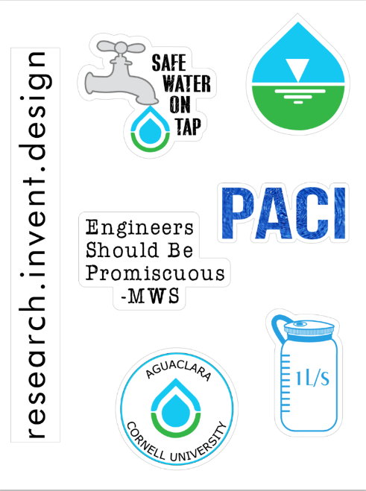

*Sticker sheet featuring new logo.*

In the future, sell the surplus items (long sleeve shirts, hats, and stickers) to new members. Also, consider creating a more formal sticker that can be given out to non-team members as well.

There are two stages for polling; the first stage involves interest, and the second stage involves ordering. For the first stage, create a series of options for merchandise and ask team leads to send out the poll in an email to gauge which color or design is most popular. For the second stage, create an order form based on the interest. Click [here](https://drive.google.com/open?id=1EYwiRwhGgwYDZKoag0zLAHnLaIvDOIEMBNGjIzdF75w) for an example of an interest form, and click [here](https://drive.google.com/open?id=1VClvT87DPHhpgz8izKYv1xPME_FXRHiY0Sjf-_M2pVI) for an example of an order form.

### Photography

This past year, Public Relations has been trying to highlight the work of both subteams and individuals. This is in an effort to inform the general public about what AguaClara does, but also to inform those on the team about what other subteams on AguaClara are working on. The photos of individuals and subteams have been used on the Facebook, Instagram, and on the upcoming website. An attempt was made to take pictures of every subteam for the website; however, the website was not completed this semester. Unfortunately, because of this, the subteam photos cannot be used because the subteams change every semester. However, some of the subteam photos were repurposed for social media, so all was not in vain.

### Team Member Interviews

So far, subteams and individuals have been interviewed for the Facebook spotlights, Instagram posts, and website. These interviews contain great quotes that can be repurposed in many ways. When interviewing team members, we often ask a few fun questions regarding hobbies, interests, and fun facts. We also ask a few serious questions about AguaClara’s impact on them as an individual, and their hopes for AguaClara in the future. There is a huge variety of questions that could be appropriate for spotlights and short bios for the website, so feel free to branch out and get creative!

## External Relations

### Alumni Outreach

Collaborate with the Research Advisor regarding alumni outreach work. Previous alumni outreach events have included an alumni reunion. There is also a mentor program currently set up that pairs alumni with undergraduate students.

Alissa Diminich is the unofficial point person of alumni outreach and Jeannette Little conducts alumni affairs within Cornell Engineering. All the contact information can be found in the official AguaClara email.

A [form](https://docs.google.com/forms/d/e/1FAIpQLSfdi5u9tnHv7q6hAP6uOGA1JAvqlI03T_lUM82Fqk0s79-j5g/viewform) has been sent out to collect alumni emails and information regarding interest in joining the mailing list, networking database, and mentor program. In the future please maintain the mailing list, create the networking database, and promote the mentor program along with the team leads and RAs who oversee this.

### Networking Database

The purpose of the networking database is to establish the connection between the current project team members and alumni. This database will serve as a platform for AguaClara students to get to know the alumni and receive guidance on careers, personal development, and life after Cornell. It is up to the students to personally go through the database to contact the alumni to whom they would like to reach out. The aforementioned form has been sent to collect the information from the alumni who are interested in the program.

In the future, please format the information provided from the form. Please personally contact Helen Hsu ([hh464@cornell.edu](mailto:hh464@cornell.edu)) for a guide of how the networking databases can be formatted. She has a template that is easy to follow but since it is personal, she is more comfortable sharing via direct message.

### Donor Relations

Public Relations handles many questions presented by donors or potential donors. The main purpose of the press kit is to reduce personal one-on-one contact by having official and consistent material available. However, please still be prepared to answer any more specific or personal questions regarding AguaClara.

Known previous Donors have been ExxonMobil. Contact information as well as documentations on all previous interactions can be found in the official AguaClara email.

### AguaClara Reach Relations

AguaClara Reach is a crucial partner of AguaClara Cornell. They are based in Ithaca and is the connecting string between the project team at Cornell and local organizations and communities. Much of our image and mission need to be consistent and non-contradictory.  It is essential to keep them updated on any new major projects that may involve the overall AguaClara or AguaClara Cornell brand. For example, they have been heavily involved with the re-branding process of AguaClara Cornell. The main point in contact for AguaClara Reach is Maysoon Sharif. Her contact can be found in the official AguaClara email.  Click [here](https://www.aguaclarareach.org/) for their webpage.

# Section III: Notes and Suggestions

## Tips and Advice

### Management

The Public Relations team has a lot of responsibility. Please divide up the work accordingly. In previous years, members have been responsible for their respective projects, but we all work on the projects together. For larger teams, we have also broken up into subgroups. Please organize your groups according to what you feel is best.

### Software

The Microsoft Student Advantage program allows registered students to download and install the current version of Office. Office 365 Pro Plus includes Word, Excel, PowerPoint, Outlook, OneNote, Lync, and, for Windows only, Access, Publisher, and InfoPath. Publisher will be valuable to you, especially when creating templates for promotional materials. Note that many of the existing templates were made in Publisher. Do not be intimidated by Publisher if you have never used it; it is similar to Word but with more of an emphasis on graphics rather than text.

## A Parting Motivational Note

Being a part of AguaClara means that you are a part of something larger than yourself. The purpose of AguaClara is not to win a competition or a prize, but to impact communities and the world on a larger scale.

As things get tough, remember that you are among talented, bright, and dedicated students who care about and work towards the same mission and goal.